Домашние задания на 07.02.-14.02. 6 «Б» класса
- Русский язык
- Литература
- Тыва дыл
- Торээн чогаал
- Математика
- 07.12.22 – п.27 с. 154 повторить, № 943, 945, 928.
- 08.02.22 – п.27 с. 154 повторить, №944, 946, 949(а).
- 09.02.22 – п.27 с. 154 повторить, № 932, 933, 935.
- 10.022 – п.28 с. 159 прочитать, рассмотреть примеры,
№ 967, 968
- 11.02.22 – п.28 с. 159 повторить, №969, 970, 973.
- 14.02.22 – п.28 с. 159 повторить, № 959, 961, 962.
- История
09.02.22 – §6 Правление князя Владимира. Крещение Руси. Ответить на вопросы к параграфу письменно.
10.02.22 – §7 Русское государство при Ярославе Мудром. Ответить на вопросы к параграфу письменно.
- Обществознание
08.02.22 – §11 Отношения с окружающими. Прочитать, сделать конспект.
- Биология

- География
11.02.22 - §18 Атмосфера. Нарисовать рисунок, сделать конспект.
- Английский язык
1 подгруппа (Айчек Айдашовна)

6 класс
1 урок:
Используйте глаголы в скобках в форме Present Continuous или Present Simple
- I __________English exercises twice a week. (to write)
- My friend ________ his homework in the afternoon as a rule. (to do)
- My sister __________ her homework now. (to do)
- Don’t shout! The baby _________ . (to sleep)
- The baby always___________ after dinner. (to sleep)
- What_______ you _________ now? (to read)
- What books_______ you_______for your literature lessons? (to read)
- What _________your mother usually________ for lunch? (to cook)
- ________ she __________a cake now? (to cook)

2 урок:
Найди перемешанные слова и переведи с помощью словаря стр. 63 Puppet show
Модуль extensive reading 6
Vgloe –
Raminetote –
Ppteu-
Csorsis –
Denwoo –
Ingstri-
Catedue –

3 урок:
Образуйте составные существительные
- House A. Day
- Wind. B. Paper
- Basket. C. Surfing
- News. D. Work
- Birth E. Ball

2 подгруппа (Айланмаа Болат-ооловна)
6 класс, 6 module урок “Pastimes”
Задания на 07.02-14-02
- Переведите слова, используйте словарь учебника
bowling alley –
cinema -
fitness centre –
football pitch –
martial arts club –
museum -
skating rink -
spa centre –
swimming pool –
tennis court –
theatre –
- Повторите правило, выполните следующее упражнение
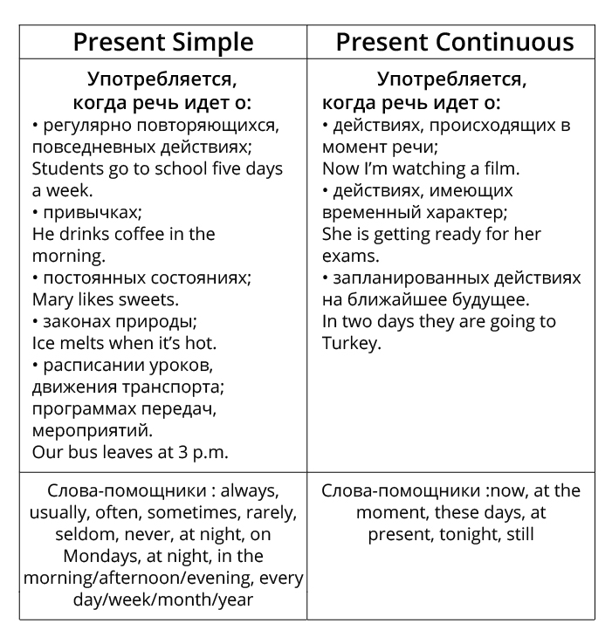

Grammar
Choose the correct word.
1. I … to school from Monday to Friday.
a. goes b. go c. am going
2. My parents never … on Sundays.
a. works b. work c. are working
3. He … at the moment.
a. swims b. swim c. is swimming
4. Students … an English lesson at the moment.
a. doesn’t have b. don’t have c. aren’t having
5. Mila usually … with her friends on Saturdays.
a. goes b. go c. is going
- Прочитайте текст, заполните таблицу.

Reading
Read the text and fill in the table.
What do American teenagers do in their free time?
American teenagers spend their free time doing a lot of different things. They love to watch television or rent videos. Often young people meet at a friend’s house to watch videos together. Young Americans also enjoy going to the movie theatre, both to watch movies but also to “hang out”. They also go to the large concerts whenever their favourite band or pop singer comes to town.
Teenage girls like to read fashion magazines and magazines about handsome, famous actors and singers. They also like to go shopping. Teenage boys like to play sports, baseball, basketball, football or soccer. Many boys read magazines about rock groups or cars and trucks. It is often the dream of many teenage boys to own their own car.
Stereotypically young Americans don’t like to spend time alone. They don’t read books unless it is absolutely necessary. Like most Americans, young Americans like to work because they like to have money. It’s difficult to find free entertainment in America. Young people spend a lot of money.

Both American girls and boys | American girls | American boys
play sports, baseball, basketball, football or soccer read magazines about rock groups or cars and trucks

watch television rent videos meet at a friend’s house to watch videos together go to the movie theatre watch movies “hang out” go to the large concerts don’t read books work spend a lot of money

read fashion magazines and magazines about handsome, famous actors and singers go shopping

- Технология
Девочки.
10.02.22 - §16 прочитать. Тема: Моделирование плечевой одежды.
Мальчики.
10.02.22 - §16. Технология соединения деталей из древесины. Прочитать, выписать правила безопасной работы.
- Физическая культура
- ИЗО
- Музыка

